

**BRAVE**

**STIRLING**

**Referral Form**



**The Bit About Me**

**My name**

**My date of birth**

**My current living**

**circumstances**

**Address and phone number**

I am happy for you to call me Yes/No

I am happy for you to text/WhatsApp me Yes/No

**These people are**

**important to me**

Examples: friends, family, partner?

**I get other help from...**

Examples: health, education, social work, or any others?

**Legal Status**

**Child Protection Register**

**My gender identity**

**My ethnicity**

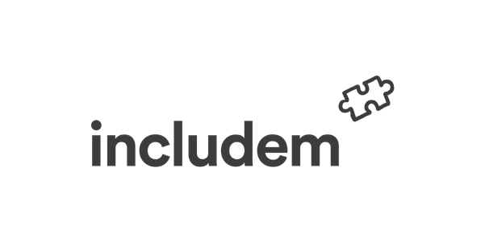

**I have additional**

**support needs**

**My religious/ cultural and**

**spiritual needs**

**and preferences are...**



**If this is not a self-referral, is the young person/family aware**

**of the referral to includem, what are their views and what has**

**their involvement been in this decision?**

**If not, why not and how are we going to talk to the young**

**people and family about this?**

**If this is a self-referral, where did you hear about the Brave**

**Project?**



**Here is a bit about my family. These are the important things that I want you to**

**know just now.**

**These things are working well for me...**

**Other people are worried about me because....**

**What worries me...**

|  |
| --- |
| **Based on the things I do; these are things that can help keep me safe. To keep me safe I need you to...** |
|  |



|  |
| --- |
| **Here are my hopes for the future...**  **My friends and family hope that I ....** |
|  |
| **Here are some things that I like and that I am good at or things that I would to try.** |
|  |



**I use the following alcohol/substances...**

**And substances I am aware of...**



**BRAVE Outcomes**

**Families are Strengthened**

**Young Person has improved physical health**

**Young Person has improved wellbeing and resilience**

**I think I need_____ number of visits per week**



**I would like a worker who is... (I’ll circle what is important to me)**

Accepting

Adventurous

Arty & crafty

Athletic

Thoughtful

Understanding

Boldness

Brave

Calm

Caring

Cautious

Cheerful

Confident

Daring

Dedicated

Dependable

Easygoing

Glamourous

**This is also important to me.........**

**The includemy bit...**

**Primary Objective: To reduce risk taking behaviour**

**Structure of support per week: __ and __ total including travel**

Self-

Education

Children

& Families

Social Work

Health

Youth

Services

Change,

Grow, Live

Young Person’s

Substance Use

Services

Stirling

Champions

Board

Adult Justice

Services

